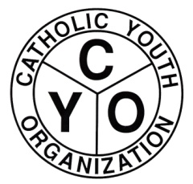
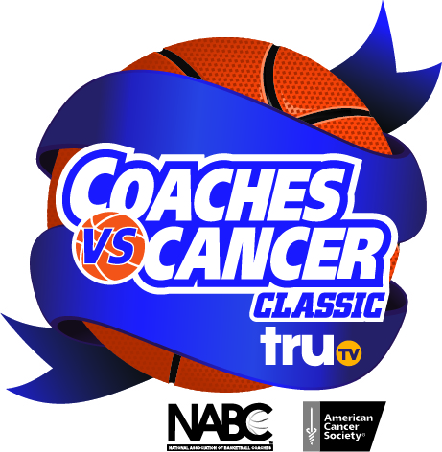

Friends and Family get in on the action on one of college basketball’s premier events. A portion of each purchase goes back to the Catholic Youth Organization.
COACHES vs. CANCER CLASSIC @ BARCLAYS CENTER
FRIDAY NOVEMBER 21st at 7:00pm (CYO NIGHT)
SEMI-FINAL DOUBLEHEADER
SATURDAY, NOVEMBER 22nd at 7:00pm
Game 1: Consolation Game Game 2: Championship Game
UPPER LEVEL SEATS (MID BOWL CORNERS AND UPPER BOWL) FOR $13.50. (Regular on-line price is $19.95 or more )
PURCHASE HERE:
https://oss.ticketmaster.com/html/go.htmI?l=EN&t=nets1&o=11012575&g=22838
PROMO CODE: CYODOB (not case sensitive)
If you have any questions, please contact the CYO office @ 718-281-9548

