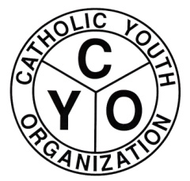

Code of Behavior: Athletes, Coaches, Spectators

R RESPONSIBILITY: of all Athletes, Coaches and spectators to conduct
themselves in a manner that displays pride and a positive image for your
children and your parish.

E ENCOURAGE: respect for authority, fairness to others and self-control.

S SPORTSMANSHIP: Win or Lose!!!! Lets remember, treat all officials,
Players and opponents as we would want our children and ourselves to be treated!

P PLAY: Make the game fun for all kids and yourself. Be positive. Don’t
pressure your child and remember, WINNING ISN’T EVERYTHING.
E EXAMPLE: Avoid criticism and foul language. Remember, ACTIONS
SPEAK LOUDER THAN WORDS!!!!
C COOPERATION: Realize, we are here with one purpose in mind. Be
supportive and understanding of all coaches, scorekeepers, referees and most
importantly our children!
T TEAMWORK: Each member of the team is just as important as the next.
Avoid yelling or blaming anyone for what you perceive to be a mistake. Remember we all make mistakes!!!!

Thank you for promoting the goals of the CYO. Remember, Referees, Parish Reps, CYO Officials, all have the authority to eject any and all spectators who violate any of the above guidelines. Anyone refusing to leave when requested may subject his or her team to forfeiture.

